TA 9752 MON Improving Extractive Sector Governance, Mongolia
Progress report for 2021

Content
Brief introduction 2
Output I. Commitment to the Extractive Industries Transparency Initiative standard maintained and improved 5
Updating EITI Reporting templates, Mongolia EITI website, and social networks 5
Organization of EITI Reporting for 2020 6
The government procurement process for the 2020 EITI report 7
Output II. Legislation to improve transparency in the extractive industry identified 9
Work of legal Consultants in finalizing of Law on transparency in MRS 9
Output III. Review of opportunities for better information dissemination and public monitoring of extractive sector activities conducted 11
Communication with Subnational councils 11
Training activities. 12
Expanding cooperation with International Finance Corporation, Open Society forum, and Professional associations 13
The meetings of the Multi-Stakeholders Group (MSG) 14
The meeting of the National Council (NC) 16
Validation preparations 16
Recruiting Communication specialist 17
Financial and procurement reporting of Mongolia EITI Secretariat 17
Planned Activities for 2022 19

Brief introduction
In the early 2019, Mongolia EITI Secretariat was finally transferred from the Prime Minister’s office to the Ministry of Mining and Heavy Industry. The Ministry had taken all necessary efforts to secure adequate budgetary allocations. In July, 2019 MOF, MMHI and ADB have agreed to fund EITI in Mongolia through TA 9752 MON Improving Extractive Sector Governance, and signed a respective agreement.
As result of these assistances Mongolia EITI activities had been normalized and so far Mongolia EITI produced a Mongolia EITI 13rd Report-2018 by the end of 2019, and 14th Report-2019 by the end of 2020, and 15th Report by the end of 2021. The Reports are available in Mongolian and English languages at Mongolia EITI website-www.eitimongolia.mn. http://www.eitimongolia.mn/p/33. As well as, Mongolia EITI and project team successfully implemented a Work Plan for 2020/2021, despite complications created by COVID-19 pandemic and lockdowns.
Mongolia EITI Secretariat planned to take following innovative measures for 2021 and accomplished partly:
- Systematic disclosure has been introduced in 2021 and updated for coming years; - Legal regulation of systematic disclosure is included in the draft of the law on transparency in the Mineral Resources sector, which is now in the list of legislation to be deliberated in 2021 Autumn session of the State Great Hural(Parliament).
- Subnational councils are reactivated in 2021 and have more capable; - Subnational Councils have reactivated, every 2 months they meet online to exchange information and share experiences on activities and coordinate activities.
- Cooperation with other organizations such as IFC, Open Society Forum, and Professional Associations were more intense and impactful; - Cooperation with these organizations is intensified and focused mainly on coordination of activities in respect to Subnational Councils, drafting a law on transparency in Mineral Resources sector, and preparing publication product.
- Mongolia EITI E-portal targeted to user-friendly and customer simpler approach. – The E-reporting portal is updated and visualizes reports of companies, government entities, and Reconciled Reports of companies.

Result, impact and progress of EITI in Mongolia
- EITI reporting remains as a real illustration of accountability of Companies is increasing.

For 2006 the number of companies, which was only 64, and this figure has reached 1490 for 2018, and increased 23 times. But this figure has decreased, in 2020 it was 1472, and in 2021 it was 1419. The reason of decrease is Covid-19 pandemic and unfortunately, the pandemic still continues, everybody hopes on quick economic recovery. In 2021, MMHI has supported idea of EITI Secretariat about selection of most open company, coal mining company Tavantolgoi, which is incorporated as local property was selected as best open company and received a Ministerial acknowledgment and cup from the Secretariat.

- EITI reporting reveals an increase of accountability and leadership of Government, which reports without any obstacles.

The Government of Mongolia produced EITI, first time for 2006, which covered revenues of extractive industries from 134 companies. It is worth noting that Government has being produced EITI reports on revenues for past consecutive 9 years, covering almost companies having mineral licenses. Because of Covid-19 pandemic the number of companies in reports was 1655, which is a bit below than previous years. This fact gives all ground to consider that accountability of the Government is increasing.

- Availability of real information has increased, as EITI reporting has become electronic.

Companies and Government have reported in “paper” between 2006-2013, and since 2014 both are producing electronic EITI reports, which lead to saving valuable time, resources and papers of both Government and Companies. Mongolia EITI has updated the system with new templates, which were adopted in 2020, therefore E-reporting system covers the majority of information required by EITI Standard.

- Donations handed to central and local state organizations, which are not disclosed previously are now disclosed since 2007.

Parliament and Government of Mongolia are taking measures to regulate issues of messy donations and assistances through relevant legislative acts. In 2010 a Financial Ministerial Order No.45, in 2011 a Budget law, and its art. 25, and in 2012 a law on the prevention of conflict of interest and regulation of public and private interests in public service, and its art.17.1, 17.4 have been adopted and regulate issues related to donations, which are present great progress in this aspect.

- Information on natural rehabilitation work and relevant deposits are disclosed on annual basis. Starting 2017 Report, companies are disclosing used water and disposal of waste.

Mongolia is disclosing natural rehabilitation work since 2007 every year, used water and disposal of waste, since 2017, which are not in the EITI standard and is implementing this very special requirement, which can be considered beyond EITI standard.

- Subnational EITI branches are established in rural areas and capital cities and give opportunity to increase communication between companies and local areas.

Mongolia has implemented many activities of good practice in rural cooperation, there is one real illustration, that is now there are functioning Subnational EITI councils in 21 aimags and 13 soums, capital city and 1 district. Starting from 2021, Subnational Councils and Secretariat are meeting every 2 months online, to discuss and exchange ongoing and future activities, and a pilot project Most open aimag initiated among Gobi region’s 4 aimags, where many mining and mineral transportation activities are taking place.

- There are some cases that EITI report and its information was used to resolve some constructive discussion.

There was discussion over whether Boroo gold company has paid any tax or not, so EITI report was used as reference tool to settle this dispute. Another case of Energy Resource company, that used EITI data in their efforts for better understanding of company’s activities.

- Contracts became available for public online and are true sources of information.

Open Contract website was developed under agreement with MMHI in 2019 and now it contains more than 800 contracts concluded between company and Government entities. The website now is handed to the EITI Secretariat, and MMHI has approved a procedure how to regulate relations in connection to this web site.

- Data of beneficial ownership has become available at EITI website and law on public information is enacted.

291 companies in 2020 and 687 companies in 2021 have reported and disclosed their beneficial owners under new reporting online template. The Parliament of Mongolia has passed in December 2021 the law of public information, under which Government will disclose 67 type of information collected at Government information system, and one of them is data of beneficial ownership, collected at State Registration General Department.

The following activities have been implemented within the scope of each output in the Technical Assistance Report of ADB in 2021, namely:

Output I. Commitment to the Extractive Industries Transparency Initiative standard maintained and improved

Updating EITI Reporting templates, Mongolia EITI website, and social networks

Updating of EITI Reporting templates continued, and missing information on the expenditure of geological work, offsetting of individual income tax, capital expenditure, and paid stamp fee and charges to all Government organizations, or last portion of templates was included into E- Reporting templates. The work was executed with assistance from an Interactive IT firm that created and developed this system from the very beginning. However, the visibility of the Companies’ 2020 report is still not resolved, because the free system software is outdated. It is in process of repair under Contract with Leader Vision Group LLC, which is selected at the end of Tender selection. The Contract is approved and ongoing.

The Secretariat with assistance from a former IT consultant renewed the existing Mongolia EITI Website, now the Secretariat is continuously updating published data on the website. Development technology issues have been resolved, as problem was that has not been updated since it was first developed. Besides, the user interface and speed have been improved. With the cooperation of the IFC specialist, we have been preparing several infographics and publishing them on the website and social networks.

Another set of updates of EITI Reporting was developed by a sub-technical group established by EITI MSG in 2021 and submitted to the National Statistical Committee for approval, which will require Companies to report additionally annual plan (1-2 years) of mining companies, detailed information of export, procurement, and employment, including average salary, and also State organizations to report on disbursement of donation and detailed information on economic impact and projection of the extractive sector.

A new Communication specialist administers the Mongolia EITI website and social networks such as Facebook live and Twitter, and regularly updates posts.

A renewal of MMHI official website

Early April 2021, MMHI requested ADB to upgrade its official website with support from ADB’s TA-9752 MON on Improving Extractive Sector Governance.

In accordance with ADB approval, Mongolia EITI coordinated communication between MMHI and the development company for the renewal of the website. On April 8, the IT admin prepared the TORs for the renewal of the MMHI official website to make the website more user-friendly and faster and MMHI has approved it. Open Soft LLC was selected from 5 bidders based on the evaluation made on May 5th, 2021, and the contract was signed on May 11. But MMHI has proposed some additional requirements, which are expected to be confirmed with the developer in written form. After resolving this issue, the work under Contract was completed by the middle of November 2021.

We estimate the progress of activity with 100 percent.

Organization of EITI Reporting for 2020

It is estimated, 2240 mineral license and petroleum contract holding companies, or 1160 companies with exploration license, 1060 companies with a production license, 20 companies with petroleum production sharing agreement have to produce EITI report for 2020 under new reporting templates.

Total 1419 companies have produced their EITI reports at E-portal. The project team has been communicated by phone, SMS, and E-mail provided methodological advice to companies in producing EITI reports, and received some visitors when it is complicated for them to produce EITI reports.

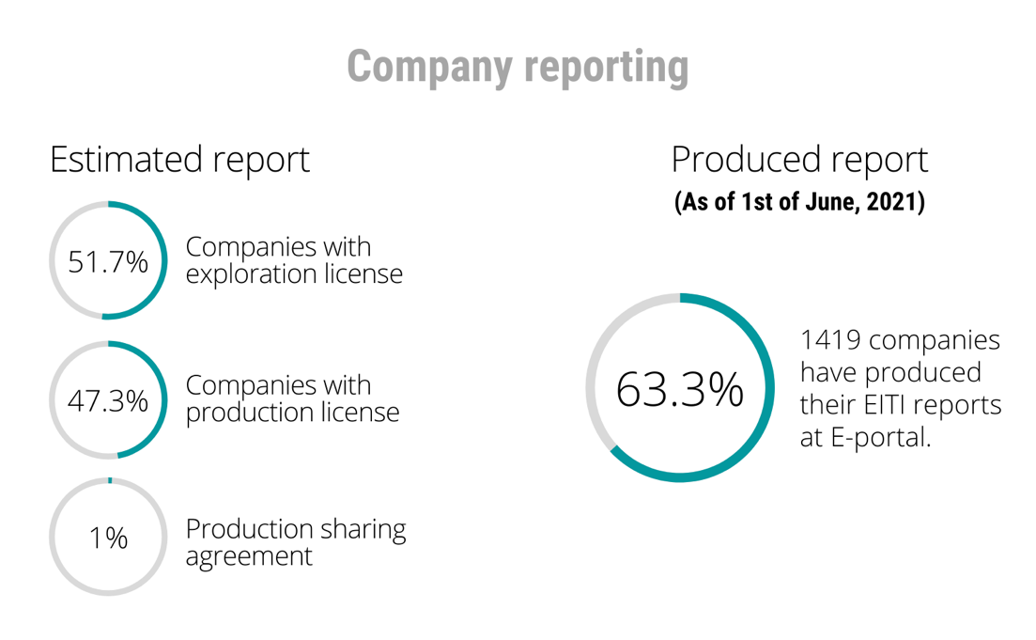
The Secretariat updated the E-reporting portal with the missing section of templates as mentioned above and conducted 4 webinars for company representatives on instructions that how to produce a report under new templates. The reporting period is extended due to Covid- 19 pandemic lockdowns and companies continued reporting at the end of May.

A similar activity has been conducted by the Secretariat in relation to EITI Reporting by the all-level Government organizations, including ministries, agencies, aimag, and districts, which have received revenue and any fee from the extractive sector and reporting process completed by the middle of July 2021.
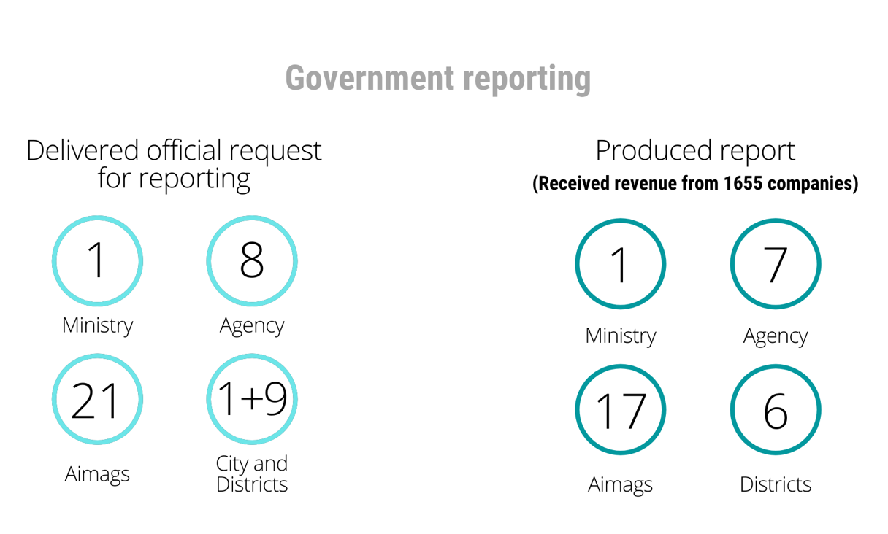

The Secretariat had delivered an official request to 1 ministry, 8 agencies (taxation, mineral and petroleum, customs, state inspection, state policy, labor, and social care, standardization and measurement, and social insurance and benefits), 21 aimags, Capital city, and 9 districts to produce EITI reports on revenue from extractive companies through Mongolia E-reporting portal and provided relevant templates, guideline, and password.

As a result of these activities and the Secretariat 7 agencies such as General Taxation Department, Minerals Resources and Petroleum Authorities, General Customs Administration, General Department of Social Insurance, Department of social care and service, State agency of Professional Inspections, Assay control of the department of National Standardization and measurement, 17 aimags except Bayankhongor, Umnugovi, Sukhbaatar and Khovd, 6 districts except Bagakhangai, Bayangol and Khan-Uul have produced EITI Report for 2020.

We estimate the progress of this activity with 90 percent implementation.

The government procurement process for the 2020 EITI report

According to Work Plan for 2021, there would have to be the following activity related to the government procurement for the 2020 EITI report in the first quarter of 2021.
- establish an evaluation committee in the Ministry of Mining and Heavy Industry under related laws;
- produce terms of reference of tender and tender documentation;
- approve terms of reference of tender and by MMHI;
The Evaluation Committee has been established in early March at MMHI, by order of the State Secretary of MMHI, consisting of 3 representatives of MMHI, 2 representatives from NGOs, and two from the Secretariat.

MMHI has approved the term of reference for 3 lots of consultancy services in early March. The lot No.1 is the production of Mongolian EITI 2020 or 15th Report but the flexible format, Lot No.2 is upgrading Mongolia E-reporting system, and lot No.3 is study work of capacity of Mongolia EITI Subnational Councils, and production of the work plan to upgrade Subnational Councils.
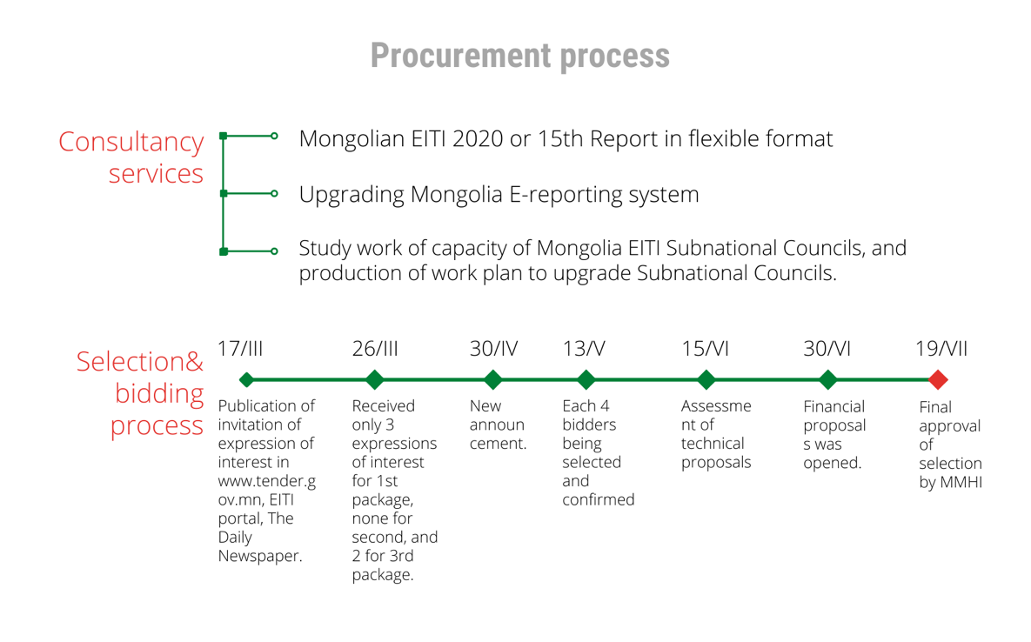
The Selection and bidding process has started on 17th March with the publication of invitation of expression of interest both at the Government Tender site, EITI portal, and one of the central newspaper “Udriin sonin” the same day.

By the 26th of March, the Secretariat has received only three expressions of interest for the 1st package, none for the second, and two for the 3rd package.

However, after reviewing of expressions, two of 3 in the 1st package had few of some relevant documents, therefore, the shortlist of all 3 packages could not be created, thus another announcement or extension is scheduled as the law required.

Under the re-announcement on April 30th, 2021, the final short was created for each lot on May 13th, and there were each 4 bidders being selected and confirmed by MMHI.

An assessment of technical proposals was conducted on June 15th, 4 bidders, namely 2 for lot No.1, each 1 for lot No.2 and 3 have received sufficient scoring and financial proposals was opened on June 30th, and recommendations had been delivered to MMHI.

But the law required to extend the tender duration, therefore, there was an official request from MMHU to MOF, which later had confirmed the extension.
As result, 3 contracts or Contract with Grant Thornton audit LLC, Leader Vision Group LLC, and Human Development Research training center are signed and approved by MMHI and Contractors entered into work by the end of July of 2021. The Tender Committee had meetings 14 times, and meetings were online and minutes are recorded.
After the contract is concluded, the Secretariat jointly with EITI MSG organized an Inception seminar with Grant Thornton and finalized scoping of the Contract work for the 2021 Mongolia EITI Flexible report.

Under Contract with Grant Thornton audit LLC, the Mongolia 2020 EITI 15th Report was produced covering reconciliation reports of 60 leading companies specialized in minerals such as copper, gold, and coal, and disclosed information in accordance with EITI 2019 Standard.

Under Contract with Leader Vision Group LLC, the Mongolia EITI E-reporting portal was upgraded and accommodated all amendments to reporting templates, visualizes reports of Company, State Organizations, and reconciled reports of Companies.

Under Contract with Human Development, report on Sub-national councils, research work, a draft of plan actions and strategy were produced and Mongolia EITI MSG and Secretariat will take actions based on these findings for better Sub-national activities.

We estimate the progress of activity with 100 percent.

Progress of implementation of Output I: About 96.6 percent.

The highlight of the progress of achievement of Output I: The Mongolia EITI 2020 Report is produced and published to the public, 1419 companies, and 7 agencies, 6 districts, and 17 aimags produced their EITI 2020 report, The tenders and consecutive Contracts have been completed successfully, achieved their target.

Output II. Legislation to improve transparency in the extractive industry identified

Work of legal Consultants in finalizing of Law on transparency in MRS

The International and national legal experts have worked on the preparing final version of the draft law and introduced their version to the legal working group of MMHI.

Their version was accepted with the notion that there would be a small legal team, which would merge old and new versions, and create a final version within the shortest possible time and then MMHI would proceed with it for Cabinet review.
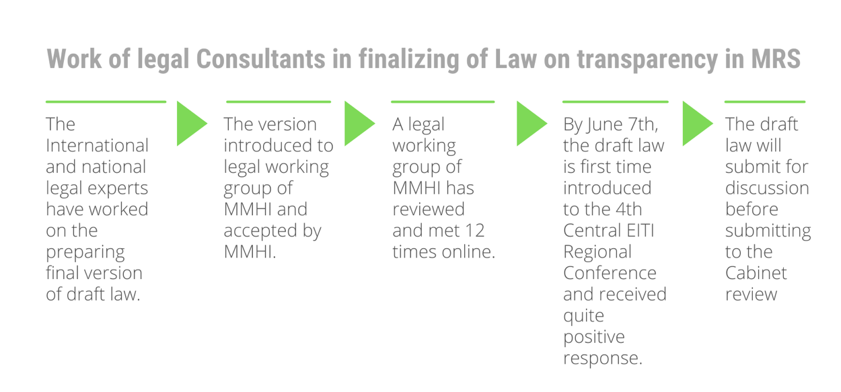
The International legal expert conducted research of international experiences in the Transparency law in order to improve the draft of the law on transparency of Mongolia and he presented it to the legal working group of MMHI.

A legal working group of MMHI has reviewed and met 12 times online, and finalized the last version by June 7th and the draft is now under internal review of MMHI. MMHI has revised timeline of this law process and will submit to the Cabinet hearing before autumn session of State Great Hural, which is usually starts by early October.

A draft law is first time introduced to the 4th Central EITI Regional Conference and received a quite positive response.

There was new discussion on this law that Minerals law, which is also under new redaction, has provisions of transparency and therefore basics provisions of transparency law may be incorporated into this draft. But MMHI still considers this option and has not issued a decision yet.

The Secretariat participated in a meeting with Mr.G.Zandanshatar and agreed to organize a Parliament consultation of this draft.

The Secretariat has developed a plan of action to promote advocacy of the EITI law draft to improve knowledge and awareness of the politicians and organized online meetings with representatives from Transparency International, the Open Society forum, NRGI, IFC, and other stakeholders.

Progress of implementation of Output II: 60 percent.

The highlight of the progress of achievement of Output II: The international and national legal experts have produced a new law version, which is merged with the old version and conducted research of international experiences in the Transparency law, and MMHI has completed drafting a final version for discussion. A draft of planning for advocacy of the EITI law draft to politicians and the public was produced.

Output III. Review of opportunities for better information dissemination and public monitoring of extractive sector activities conducted

Communication with Subnational councils

The Secretariat had consulted with all aimag Subnational EITI Councils and agreed to have a regular online meeting at least once every 2 months.

So in February, the team met with Subnational councils, consulted on delivery of 2020 Aimag EITI Report and Plan for 2021 Work, also familiarized with the content of the collaboration agreement signed between the Minister of Mining and Heavy Industry and Governors of 21 aimags, specifically with EITI related provisions.

The April meeting was about counseling to Subnational Councils, methodological advice on how to draft Work Plan, and it was provided by professionals from NGOs.

The two meetings on August 19 and 27 were about the implementation of the work plan of Aimag subnational councils for the 1st half of 2021, consulted and agreed on organizations of EITI Regional conferences, but because of restrictions caused by Covid-19 Pandemic in several aimags and Ulaanbaatar, they will be organized online.
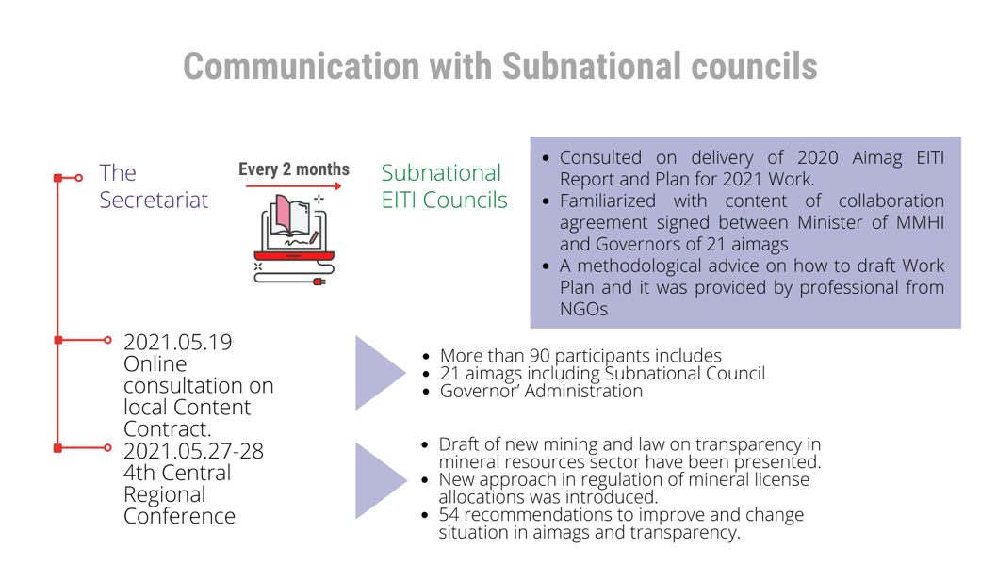
In May, the Secretariat had organized online consultation on local Content Contract, where all 21 aimags including the Subnational Council, Governor’ Administration participated and received counseling on how to conclude the contract, what should be focused on before concluding, and what kind of monitoring should be after the conclusion and over the implementation of contracts. There were more than 90 participants and it was shared live online through Facebook. Pre and Post consultation assessments of the knowledge of participants by questionnaire had been carried and findings were published on the website and Facebook.

In May, the Secretariat and subnational Councils of 8 aimags of the central region organized a 4th Central Regional Conference, but it was the first time in online, because of the Covid-19 pandemic lockdown.
- Draft of new mining and law on transparency in mineral resources sector have been presented by MMHI.
- A new approach in the regulation of mineral license allocations was introduced by Mineral Resource Petroleum Authority.
- MOF presented a detailed view of the Local Development Fund and had a constructive discussion on this aspect.

In October, the Secretariat and subnational Councils of 6 aimags of the Western region organized a 3rd Regional Conference, but it was online, because of the Covid-19 pandemic precautions.
- Draft of new mining and law on transparency in mineral resources sector have been presented by MMHI.
- A new approach in the regulation of mineral license allocations was introduced by Mineral Resource Petroleum Authority.
- EITI Quiz AHA was introduced by the Secretariat very first time, the winner was a representative from Company Constituency.

In December, the Secretariat and subnational Councils of 3 aimags of the Eastern region organized a 3rd Regional Conference, but it was online, because of the Covid-19 pandemic lockdown.
- Draft of new mining and law on transparency in mineral resources sector have been presented by MMHI.
- A new approach in the regulation of mineral license allocations was introduced by Mineral Resource Petroleum Authority.
- EITI Quiz AHA was introduced by the Secretariat also, winner was a representative from State Organization Constituency, this time.
At the end of these conferences, participants have agreed on recommendations to improve and change the situation in aimags and transparency, which were later delivered to relevant organizations for further consideration Pre and Post-conference assessments of the knowledge of participants by questionnaire had been carried and findings were published on the website and Facebook.

Training activities.

The training activities, for the time being, are all halted due to Covid-19 precautions in Mongolia.

Therefore, Secretariat had organized 4 Webinars for companies to help them to produce EITI 2020 Reports, using Google Meet platforms. Companies are more participating in the training than last year.

The Secretariat in cooperation with IFC, Ministry of Justice and Internal affairs training of journalists on August 30th, the main topic was open data format, and introduction of the draft law on the information of public under which about 60 types of information, including beneficial ownership.

Information of the training and seminars

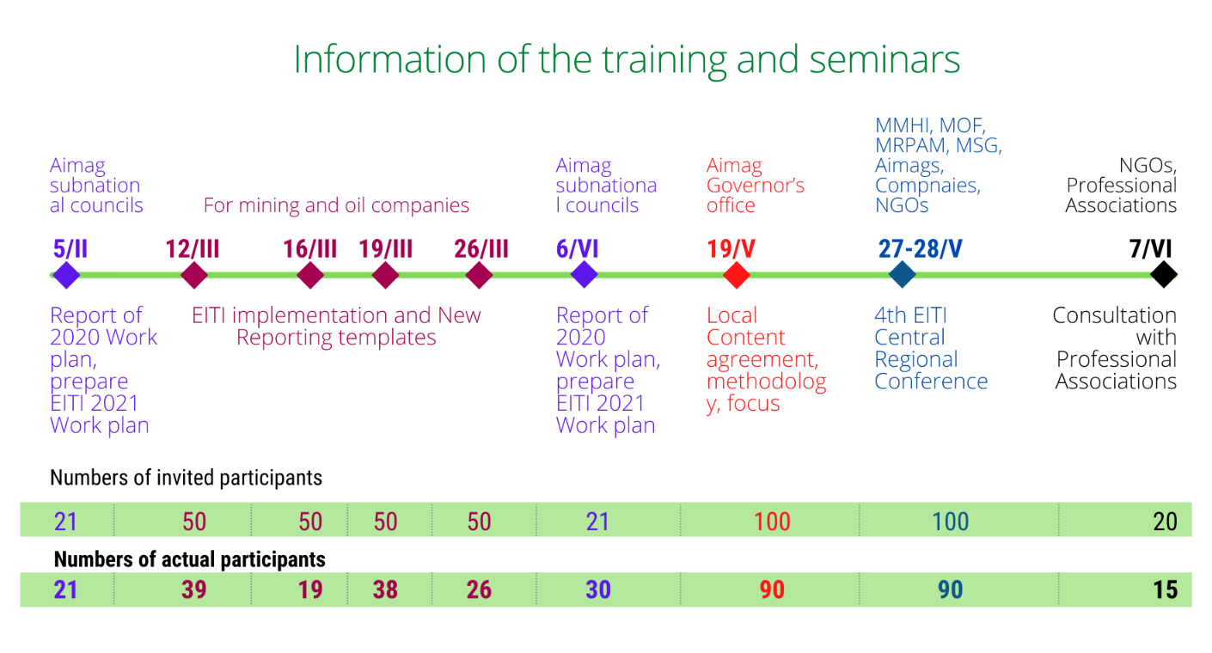

Expanding cooperation with International Finance Corporation, Open Society forum, and Professional associations

The Secretariat has an ongoing consultation activity with IFC and Open Society forum to jointly implement some communication activities such as regional conferences, training of Subnational Councils and some activities such as Hackathon and training of trainers this year in order to systematic disclosure. Some cooperation activities are planned in IFC 2021 working plan through Mongolian EITI requests. Some online meetings with these organizations have been organized for planning.

As MSG has decided Open Contract website, which is created by the Open Society forum, is the process of handover from the Open Society forum to the Secretariat. For smooth hand-over and further handing, a new procedure on how to run this website was developed by the Secretariat and approved by the order of the Minister of Mining and Heavy Industry. The Secretariat had organized an introductory webinar on this procedure to representatives of all Aimag Governor’s offices and EITI Subnational councils on the 18th of November with support of the Open Society Forum.

The Secretariat launched a pilot on transparent aimag among 4 Gobi regional aimags, along with MMHI, IFC, Open Society Forum, NGO Steps without border, developed all respective assessment sheets, organized training of officials of these aimags, rendered assistance, and final results will be available in 1st Quarter of 2022.

A consultation activity organized by the Secretariat with the Chamber of Commerce and Industry, Business Council, Transparency International, Mongolian National Mining Association on coordinating activities for better governance and agreed with the Chamber of Commerce to cooperate on the aspect of selection of best open transparent company along with Annual Award ceremony.

The Secretariat has organized selection of best transparent company of extractive sector, coal mining company of local property Tavantolgoi shareholding company was selected and rewarded with acknowledgement of Minister of Mining and Heavy Industry and cup of EITI Secretariat.

The Secretariat under instruction of MMHI participated in seminar of Open Government Partnership in deliberating the draft of the Annual National plan for 2021-2023, included Beneficial ownership into this plan.

The meetings of the Multi-Stakeholders Group (MSG)

The National Secretariat under the direction of MMHI organized very 1st of 2021 or the 53rd meeting Mongolia EITI Multi-Stakeholders Group on February 25, 2021, on which agreed to establish a sub-technical group for implementing a pilot project for diagnostic tools of Anti- Corruption. The group was established out of 6 members of Mongolia EITI MSG with the following composition:
- Mr.N.Dorjdari, coordinator of Natural resources governance institute, members:
- Mr.B.Gankhuyag, commissar, an officer of the Department of Prevention and enlightenment of Anti-Corruption Authorities,
- Mr.D.Enkhbold, executive director of Mongolian National Mining Association,
- Ms.B.Erdenetsetseg, secretary of Coal Association,
- Mr.L.Tur-Od, head NGO Transparency International Mongolia,
- Mr.D.Tserenjav, head of NGO Transparency Foundation,
- Mr.D.Sukhbaatar, chairman Governing body of NGO Responsible Mining Initiative for Sustainable development, and
- Mr.Sh.Tsolmon, coordinator of EITI Secretariat;
The sub-technical group has already contacted once and agreed on the selection of an independent researcher to study the issue, his/her TORs, and draft a work plan for further intervention.
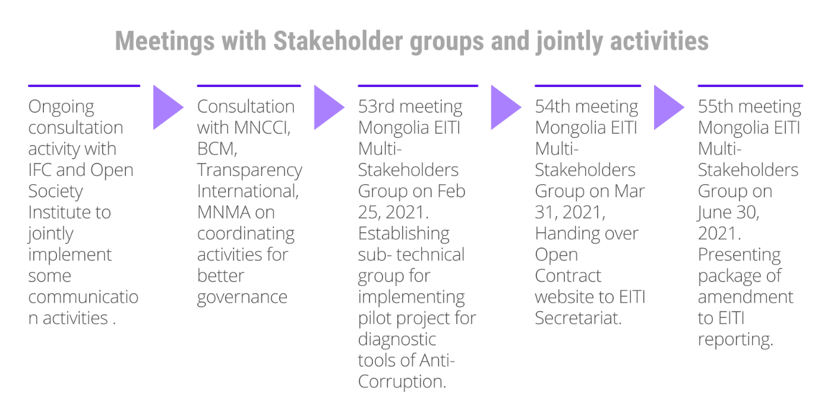
A 53rd meeting also discussed and agreed on the following:
- to deliver guidelines and recommendations on producing 2021 Work Plan to Subnational Councils;
- To assign to EITI Secretariat a duty to conduct monitoring over implementation of 2021 Work plan by Mongolia EITI Subnational Councils;
- It is agreed to organize a next meeting of the EITI Working Group between March 22-26, 2021 and the agenda would cover web site of Open Contract and its functioning.
The Secretariat under the direction of MMHI organized another or the 54th meeting Mongolia EITI Multi-Stakeholders Group on March 31, 2021, and agreed to hand over the Open Contract website to the EITI Secretariat, which will also produce procedure to administer the website, ensure preparation work for the organization of EITI Central regional conference and recommended to organize a National Council meeting and discuss on coordination of ongoing projects.

The Secretariat under the direction of MMHI organized another or the 55th meeting Mongolia EITI Multi-Stakeholders Group on June 30, 2021, and where the Secretariat had presented a progress report of activities for 1st half of 2021, and recommendations of 4th EITI Central Regional Conference. Also, it presented a package of amendments to EITI reporting, namely to disclose an operation plan for 2 years, details of export, procurement, information on donation disbursement, information of economic impact, and assumption of the extractive sector, and additional information on employment. The MSG has agreed to establish a sub technical group to elaborate more details of these amendments. The meeting reviewed the introduction of the ongoing pilot project for diagnostic tools of Anti- Corruption and agreed to hear the progress of work for the next meetings.

The Secretariat under the direction of MMHI organized another or the 56th meeting Mongolia EITI Multi-Stakeholders Group on September 30, 2021, and where the Secretariat had presented an introduction on companies and state organizations, which have not reported for EITI for the last 5 years.

The meeting also reviewed and approved report, plan of actions and findings of consultant of NRGI on methodologies on diagnosing risks of corruption through EITI data, progress of Contract work of Leader Vision Group Ltd and Human Development Research training center. The Plan of actions is integrated to Mongolia EITI 2022 Work Plan, which was approved later by the National Council.

The Secretariat under the direction of MMHI organized another or the 57th meeting Mongolia EITI Multi-Stakeholders Group on November 23 and continued on 25, 2021.

The meeting reviewed progress of implementation of Mongolia EITI 2021 Work plan and draft of Mongolia EITI 2022 work plan, draft of Mongolia EITI 2020 flexible report produced by Grant Thornton audit LLC, and other relevant issues and decided to support in principle draft of Mongolia EITI 2020 flexible report, add proposals and recommendations of MSG and submit to Mongolia EITI National Council for endorsement, to allow the EITI Secretariat to effect payment of 30 percentage of value of Contract No.24 and under its provision No.4 concluded with Grant Thornton Audit LLC to its bank account, Progress of implementation of Mongolia EITI 2021 Work plan and draft of Mongolia EITI 2022 work plan should be amended with proposals and recommendations of Members and submitted to National Council for review and approval and Draft of strategy based on baseline study of capacity of sub-national councils on capacity build-up capacity needs of EITI sub-national councils should be amended with proposals and recommendations of Members.

The meeting of the National Council (NC)

Finally, Mongolia EITI National Council organized its 20th meeting, online on the 21, 2021 endorsed Mongolia EITI 2020 or 15th Report, Mongolia EITI 2022 Work Plan, and discussed issues about companies, which have not been reported for EITI and not complied with art.48.10 of Mineral law.

Validation preparations

The Secretariat jointly with EITI International Secretariat had organized pre-validation consultation with Mongolia EITI MSG in June, launched preparatory work for Validation, which will resume on the 1st of January 2022, also webinars on Open Contract, Anti-Corruption tools, through which MSG has obtained necessary knowledge from the international community. Then in October and November, the Secretariat organized a series of webinars, consulted with MSG members and Grant Thornton audit LLC on Validation, and introduced templates on how to fill out.

The Secretariat filled out templates of Mongolia EITI stakeholder engagement, outcome and impact, and transparency collected templates filled by Grant Thornton, Mongolian Mining Association, and PWYP Coalition, and created Validation dossier and published at own web site.

The Secretariat jointly with EITI International Secretariat organized a webinar of Mongolia EITI MSG on beneficial ownership in August and updated the international community what is status of Beneficial ownership in Mongolia.

Also, the Secretariat organized another Beneficial ownership webinar of Mongolia EITI National Council and MSG with EITI International Secretariat on August 26, but with broader participants including representatives from the Ministry of Justice and Internal affairs, General department of State Registration and agreed to coordinate activities for joint efforts.

Other Communication aspects

The Secretariat jointly EITI International Secretariat and Open Ownership organized a Global launch of Opening Extractives through Disclosing Beneficial Ownership in September and disseminated relevant information and interview through media.

The Secretariat does annual reports to the online reporting system of Anti-Corruption Authorities and monitors implementation of Plan of action under the National Anti-Corruption Program.

Recruiting Communication specialist
Ms.Baigal, the communication consultant, drafted the Mongolia EITI Training module, Stakeholders mapping, Communication strategy, and communication platforms.
The Secretariat had completed a selection process for a new communication specialist, and Ms.Tselmeg launched her duties and updated Communication Strategy, which will be introduced to EITI MSG.

Financial and procurement reporting of Mongolia EITI Secretariat
A financial report on 2020 state budget financing has been produced and published on the Glass account website and delivered to the National Audit Office in the first quarter of 2021.
The Disbursement plan activities to be funded by ADB in 2021 had been submitted to ADB for approval.
Plan for World Bank funding for 2021 and 2022 had been submitted to MMHI and MOF, which later had been modified as 2022-2023, and preparations work are ongoing.
The Report on Procurement activities under State budget funds for the 1st half of 2021 is submitted to MMHI.
The Secretariat organized efficiently a procurement of 3 laptops for office needs within allocated funds, as result, it has the better technical capacity to run daily operations.
Progress of implementation of Output III: Average 100 percent.
The highlight of the progress of achievement of Output III: Most Subnational councils are actively involved in the implementation 2021 Work Plan. The online training courses for companies and 3 regional Conferences, Validation preparations were successfully organized even though having restrictions reasoned by the Covid-19 pandemic. Cooperation with other organizations has been activated and the meetings of MSG and National Council have been organized online successfully. A new communication specialist has already created some output and is more active in social networks.

Total evaluation for 2021
Items | Output | Highlight of progress
I | Commitment to the Extractive Industries  Transparency Initiative standard  maintained and improved. | - The EITI Reporting by 1419 companies for 2020 is considered quite high as a result of the Secretariat’s efforts in providing assistance to companies.  - Tender for selection of Consultancy firm for EITI Integrated Report 2020 is completed in a timely manner over and successfully.  - Improving and being simpler for E-portal was done under the Contract work.  - The website of Mongolia EITI has been renewed and updated some main data.  - The renewal of the website of MMHI is completed.  - Mongolia EITI 2020 or 15th Report is produced and published.  - Strategy and plan of actions for Sub-national Councils are prepared.
II | Legislation to improve transparency in the extractive industry identified | - The international and national legal experts have produced a new law version, which is merged with the old version.  - Legal consultants conducted research of international experiences for the Transparency law.  - Final version of the draft law is prepared by MMHI and ready for discussion.
III | Review of opportunities for better  information dissemination and public  monitoring of extractive industry  activities conducted. | - Most Subnational councils are actively working to implement the 2021 Work Plan.  - The online training courses for companies were successfully organized even though having restrictions reasoned by the Covid-19 pandemic.  - Cooperation with other supporting organizations has been activated and the meetings of MSG and National Council have been organized online successfully.  - Preparations for Validation is successfully conducted and Mongolia is ready for 2022 Validation.
Overall Progress Rate of  the Project |  | The EITI Mongolia implemented successful actions of the 2021 Work Plan even though some restrictions are occurring due to Covid-19. The total estimation of implementation is 85.5

Planned Activities for 2022
The first priority and focus of the 2022 Work Plan are to enact a Transparency law in the mineral resources sector and prepare for the State budget funding mechanism of the Secretariat.
The second priority is to pass successfully EITI Validation and preserve the current compliance status with the Global EITI Standard.
The third priority is to improve communication and use of EITI data, improve activities of Subnational councils.

---o-o-O-o-o---

Mongolia EITI 2018 report- 81 companies reported on used water and 49 companies reported on disposal of waste.
Mongolian Mining Journal, 2018 –November Edition

