[Mongolia, 2021]
MSG review of the outcomes and impact of the EITI
Contents
Introduction 1
Part I: Relevance of EITI implementation 2
Work plan (Requirement 1.5) 2
Monitoring progress 3
Innovations and impact 4
Part II: Public debate 6
Open data (Requirement 7.2) 6
Outreach and communications (Requirement 7.1) 6
Part III: Sustainability and effectiveness 9
Part IV: Stakeholder feedback and MSG approval 10

Introduction
Regular disclosure of extractive industry data is of little practical use without public awareness, understanding of what the figures mean, and public debate about how resource revenues can be used effectively. The EITI Requirements related to outcomes and impact seek to ensure that stakeholders are engaged in dialogue about natural resource revenue management. EITI disclosures lead to the fulfilment of the EITI Principles by contributing to wider public debate. It is also vital that lessons learnt during implementation are acted upon, that recommendations from EITI implementations are considered and acted on where appropriate and that EITI implementation is on a stable, sustainable footing.
The multi-stakeholder group may use this template to monitor the outcomes and impact of EITI implementation. Where information is already available elsewhere, it is sufficient to include a link to other publicly available documentation. The scope of this template reflects EITI Requirement 1.5 on work plan and Requirements 7.1 to 7.4 on outcomes and impact.
The MSG is required to review the outcomes and impact of EITI implementation annually (Requirement 7.4). The MSG is encouraged to update this document annually to monitor progress, keep track of efforts to improve data accessibility and inform work planning.
To inform Validation, the MSG is required to submit the completed form to the International Secretariat Validation team by the Validation commencement date. The period captured in this review may be the period since the previous Validation or the previous calendar/fiscal year. The MSG should clearly indicate the period covered by its review.
The MSG’s annual review of the outcomes and impact of EITI implementation should be publicly available, and stakeholders beyond MSG members should have an opportunity to provide feedback on the EITI process (Requirement 7.4).

Part I: Relevance of EITI implementation

Work plan (Requirement 1.5)
1. Basic information about the current EITI work plan.
Period covered by the current EITI work plan | [2021 Insert period covered here, e.g. 2021]
Information on how the public can access the work plan. | [http://www.eitimongolia.mn/p/10  Insert link or other instructions here]
Process for producing the current EITI work plan | The current 2021 Work Plan had been drafted by the EITI Secretariat, which submitted to EITI MSG meeting No.52 on December 15, 2020. The meeting was online because of Covid-19 Pandemic lockdown in Mongolia. MSG approved the Work Plan, which was later approved by EITI National Council by its correspondence meeting.  [Summarise the process here. Include references to MSG meetings and other events where the work plan was discussed.] Implementation of 2021 Work Plan is attached as of December 20th, 2021.
MSG approval of the work plan | [Date of approval] December 30, 2020 by the National Council.
2. Explain how the work plan’s objectives reflect national priorities for the extractive industry. Provide links to supporting documentation, such as studies or national development plans, if available.
One of core plan of actions for 2021 is enactment of law on transparency in mineral resources sector, under objective “Objective 1. Draft a law on transparency mineral resources sector in compliance with global standard and finalize”, which will implement the right of Mongolian people to know what is in natural resources sector, which will be developed into sector insuring benefits of natural resources for current and future generations that is one fundamental ongoing reforms under amendment to the Consitution of Mongolia, enacted in 2019. Link to Constituional amendment, provision 6.2 on November 14, 2019- https://legalinfo.mn/mn/detail?lawId=367
Another core was organization of study-work for possible use of EITI data to diagnose corruption in extractive sector.
The objective is “Objective 18. Implement a project on defining corruption risk with scope of EITI;”
The work was conducted by consultant team hired by NRGI, and Mongolia EITI established a subtechnical group to coordinate this work and now includes some actions for 2022 Work plan based on recommendations by the studywork. The work was based on National Program to combat corruption, Resolution No.51, endorsed by Parliament, November 3, 2016 and Work Plan 2017-2023, approved by Government, Resolution No.114, April 14, 2017, action No.4.1.6.5 link: https://iaac.mn/undesnii-xutulbur

3. Optional question: Has the MSG developed a theory of change on how EITI implementation will address the identified challenges of the sector in your country? If yes, please reference the corresponding document here.
There is no a theory of change for Mongolia EITI MSG.

Monitoring progress
4. Provide an overview of activities undertaken in the period under review and progress in achieving the objectives of the previous work plan. The MSG is encouraged to provide a summary here and to document progress in more detail in the work plan itself.
The first case of Covid-19 was registered in Mongolia in March 2020, and preventive actions such as total restrictions of outreach activities and travelling had been set up and first full scale of lockdown such as homestay was established in November 2020 and continued periodically till May 2021.
In August 2020, the Pandemic was a bit eased, then MSG could have online meeting No.51 and reviewed progress of Work Plan, tried to speed up implementation if the situation becomes more favorable.
But then there was full lockfdown in November. 2020 and many activities from Mongolia EITI 2020 Work plan have not been implemented.
The situation remained complicated until vaccination campaign and when vaccination rate is improved there was established so called “orange regime”, which is effective up to now (December 2021).
Therefore, the most activities have been implemented in form of online, MSG could meet 5 times in 2021 and National Council met once, reviewed implementation of Work Plan and gave instructions for better implementation.
National EITI Secretariat is regularly monitors implementation of activities and briefs MSG on progress of implementation, the last brief was in November 23rd, 2021, at 57th meeting of MSG, link: http://www.eitimongolia.mn/p/47
[Summarise progress in implementing the previous work plan. Provide a link to the previous work plan with a more detailed analysis of progress in undertaking planned activities and achieving each objective or attach it to this submission.]

5. Provide an overview of the multi-stakeholder group’s responses to and progress made in addressing the recommendations from EITI reporting and Validation and gaps in information in accordance with Requirement 7.3.
The multi-stakeholder group is required to list each recommendation and the corresponding activities that have been undertaken to address the recommendations and the level of progress in implementing each recommendation. Where the government or the multi-stakeholder group has decided not to implement a recommendation, it is required that the multi-stakeholder group documents the rationale.
All the recommendations given by Mongolia EITI Reports 2018 and 2019 are included in Work Plan of 2021 and implementation are monitored.Progress of recommendations from EITI Report for 2018 and 2019 as of Dec 22, 2021.docx
One specific recommendation from 2019 report was implemented in 2021, which suggested to organize and finalize the selection process of the Independent Administrator in timely manner. In that case, the selection was completed on July 30th, despite various complications caused by Covid pandemic. Progress of recommendations from EITI Report for 2018 and 2019 as of Dec 22, 2021.docx
Recommendation: | Status/progress:
 | [Has the recommendation been partly or fully addressed? How is the MSG following up on the recommendation? Has the MSG identified an agency or actor responsible for addressing the recommendation? If the MSG has decided not to implement the recommendation, please document the rationale.]
To finalize the selection process of the Independent Administrator in timely manner | It is completed, despite Covid 19 pandemic. Progress of recommendations from EITI Report for 2018 and 2019 as of Dec 22, 2021.docx
(add rows as necessary)

6. How have lessons learned from EITI implementation informed the current work plan?
One specific recommendation from 2019 report was implemented in 2021, which suggested to organize and finalize the selection process of the Independent Administrator in timely manner. Progress of recommendations from EITI Report for 2018 and 2019 as of Dec 22, 2021.docx
That was of case of lesson, and not to repeat again. As mentioned above the selection of the the IA ended on July 30th, despite various complications caused by Covid pandemic. It is worth mentioning prevous selections were completed quite late in August of 2019, in October of 2020.
Another specific lesson is need of law on transparency in extractive sector to be enacted, if not then to have EITI 2019 standard enacted as the National Standard of Mongolia creating other way around.

Innovations and impact
7. Summarise any steps taken by the MSG to exceed EITI Requirements in a way that addresses national or local extractive sector governance priorities.
MMHI and NSC (National Statistical Committee) have enacted amendment to EITI Reporting templates in 2020, and amendments cover more than what is required by EITI Standard to such as procurement, use of chemicals, water, waste disposal, impact zone and etc., which are reported online, visibility of such reported data is under construction.
MMHI has enacted a procedure how to operate Open Contract portal www.iltodgeree.mn in September 2021.
MMHI has amended annual Cooperation agreement with Aimag Governors with obligation on EITI at local area.
8. What kind of outcomes and impact have these measures resulted during the period under review?
[Explain how the MSG tracks outputs, outcomes and impact and include link(s) to any relevant documents. Summarise the outcomes and impact of efforts to ensure that EITI implementation addresses national or local extractive sector priorities. If the MSG has documented this elsewhere, please provide a link to relevant documents. Outcomes and impact can be disaggregated by constituency or beneficiary group, if relevant.]]
Output: More and more companies (about 1400 every year for last 4 years since 2017) permamently produce EITI report and comply with law provisions, and State organizations reports do cover revenues of more and more companies (more than 2000 every year for last 5 years, except 2020 because of Covid-19 pandemic restrictions. 1655 companies were in 2020 Government Report).
Outcome: Each aimag has established EITI Sub-national Council and some do post EITI data at their own website. Here is website of Zavhan aimag, link: http://zavkhan.gov.mn/180/all
Impact of EITI outreach and promotion activities for last 3 years is that 21 aimag, 13 soum, Capital city-Ulaanbaatar, 1 Khan-Uul district have established EITI Sub-national Councils.
National Secretariat briefs EITI MSG regularly on output, outcome and impact, check with link of MSG meetings.
8. If the MSG has plans to include new issues or approaches to EITI implementation, please describe these.
Another new amendment to EITI Reporting templates is under process at National Statistical Committee, which is covering disclosing under EITI template the data about GDP by MOF, production plan of companies, salaries, economic impact.
Starting from 2022, EITI Secretariat is allowed to reallocate from its limited resources of State Budget fund MNT 22 million (about $7.700) for activities of Sub-national council. The amount is not sufficient, but each aimag and Capital city EITI Sub-national council can use for promotional activities.
Contract disclosure, BO data collection and SOE data collection are included as provisions into draft law on transparemcy in mineral resources sector, which is ready since June 2021 and included into the list of legislations to be discussed at Parliament’s autumn session of 2021.
9. What kind of outcomes and impact are these plans expected to result in?
Extractive sector of Mongolia becomes full openand responsible sector, and will generate revenues for development of National economies, but will bench sector to demonstrate possibility of fulfillment of concept of New Consitution amendment from 2019.

10. Summarise the MSG’s efforts to strengthen the impact of EITI implementation in the period under review, including any actions to extend the detail and scope of EITI reporting or to increase engagement with stakeholders. The MSG is encouraged to document how it has taken gender considerations and inclusiveness into account.
1. The law on transparency in extractive sector should be enacted, and Mongolia EITI becomes mainstream of data of extractive sector. The data must be in open data format. The draft law shall require:
- Ministry of Mining and Heavy Industry,
- Ministry of Finance,
- Ministry of Natural Environment and Tourism,
- Ministry of Labor and Social protection,
- Ministry of Road and Transportation, and
- Agencies for Mineral and Petroleum Resources, State Registration of legal entities, Taxation, Customs, Land, State Property, State professional inspections, Social Insurance, Labor and Care service, and Standardization and Measurement, and
- Governor of Aimags, soums, Capital city and districs to report online, regularly and update data...\Draft law on transparency in Mineral resources sector, June 4 2021 in Mon.docx
2. For 2022, Mongolia EITI planned to organize some awareness webinar or seminar on issue of gender balance if circumstances allow,

Part II: Public debate

Open data (Requirement 7.2)
11. Open data policy and disclosures
Provide a link to the open data policy agreed by the MSG (Requirement 7.2.a) | [Add link(s) to relevant open data policy(ies) and any commentary.]  EITI Open data policy, approved by EITI National Council, Dec 20, 2016  http://www.opendatalab.mn/
Is EITI data available in open data format and publicised? (Requirement 7.2.b) | Yes, it is available in machine readable format. Attachment of Mongolia EITI Annual reports are in Excel files and available at Mongolia EITI website, with this link:  http://www.eitimongolia.mn/p/33  [EITI data refers to disclosures within the scope of the EITI Standard, including the tables, charts and figures from EITI reports.]
Has the MSG identified gaps in the availability of EITI data in open format? If yes, what kind of gaps? (Requirement 7.2.b) | So far, it is considered that there is “gap” in Mongolian EITI Reporting. The gap means the fact that disclosed EITI data is too bulky, it should be developed into more understandable, accessible and user friendly format, even to be easy to be processed for target group.
Has the MSG undertaken efforts to improve the availability of data in open format? If yes, please describe these. (Requirement 7.2.b) | EITI Reports for 2018, 2019 and 2020 are produced in Word and Excel files, and are in format to be used by various users.
Have summary data files been completed for each fiscal year for which data has been disclosed? (Requirement 7.2.c) | Annual Summary data is disclosed at the web site of EITI Internatioanl Secretariat.
What systematically disclosed data that is in the scope of EITI disclosures is machine readable and inter-operable? (Requirement 7.2.d) | Yes, it is a machine readable. Mongolia’s EITI Reports for 2018, 2019 and 2020 are produced in Word and Excel files, and are in format to be used by various users.

Outreach and communications (Requirement 7.1)
12. Describe the MSG’s efforts in the period under review to ensure that information published about the extractive sector is comprehensible and available in appropriate languages.
www.eitimongolia.mn, and http://e-reporting.eitimongolia.mn/- are 2 main sources of data are available.
The Secretariat administers both sources of data, does update of data and learnt new applications such Flourish, Canva to improve quality of data publication, infographics and upgraded website under Contract with Sodon solution and updated E-reporting portal by Leader Vision group ltd, both are Mongolian software development companies.
Translation of published data into English should be improved.
For this moment, Mongolian language is official language, but it may be translated into local language such as Kazakh, or Buriyat when the time is up.
13. Describe examples of use of EITI data.
Web site of Mongolia EITI Secretariat www.eitimongolia.mn its accounts https://www.facebook.com/EITIMongolia and https://twitter.com/eitimongolia are main sources of channeling EITI data.
[Document instances of use of EITI data in various formats, whether from MSG members or any stakeholders. Examples of types of EITI data use could include:
- Print and broadcast media coverage of stories referencing EITI data
- Research and analytical studies drawing on EITI data
- Advocacy and lobbying notes referencing EITI data
- Parliamentary submissions or proceedings drawing on EITI data
- Etc.
Provide links to supporting evidence where available.]
Anecdotal evidence can also be recorded, for instance in the following way:
[This person / group ] has used [type of data in the scope of EITI disclosures] to do [what the data was used for / what problem did it solve.]

14. Provide information about outreach events organised to spread awareness of and facilitate dialogue about governance of extractive resources, building on EITI disclosures.
1. Report for 2020 Activities and 2021 3rd Activities are attached.
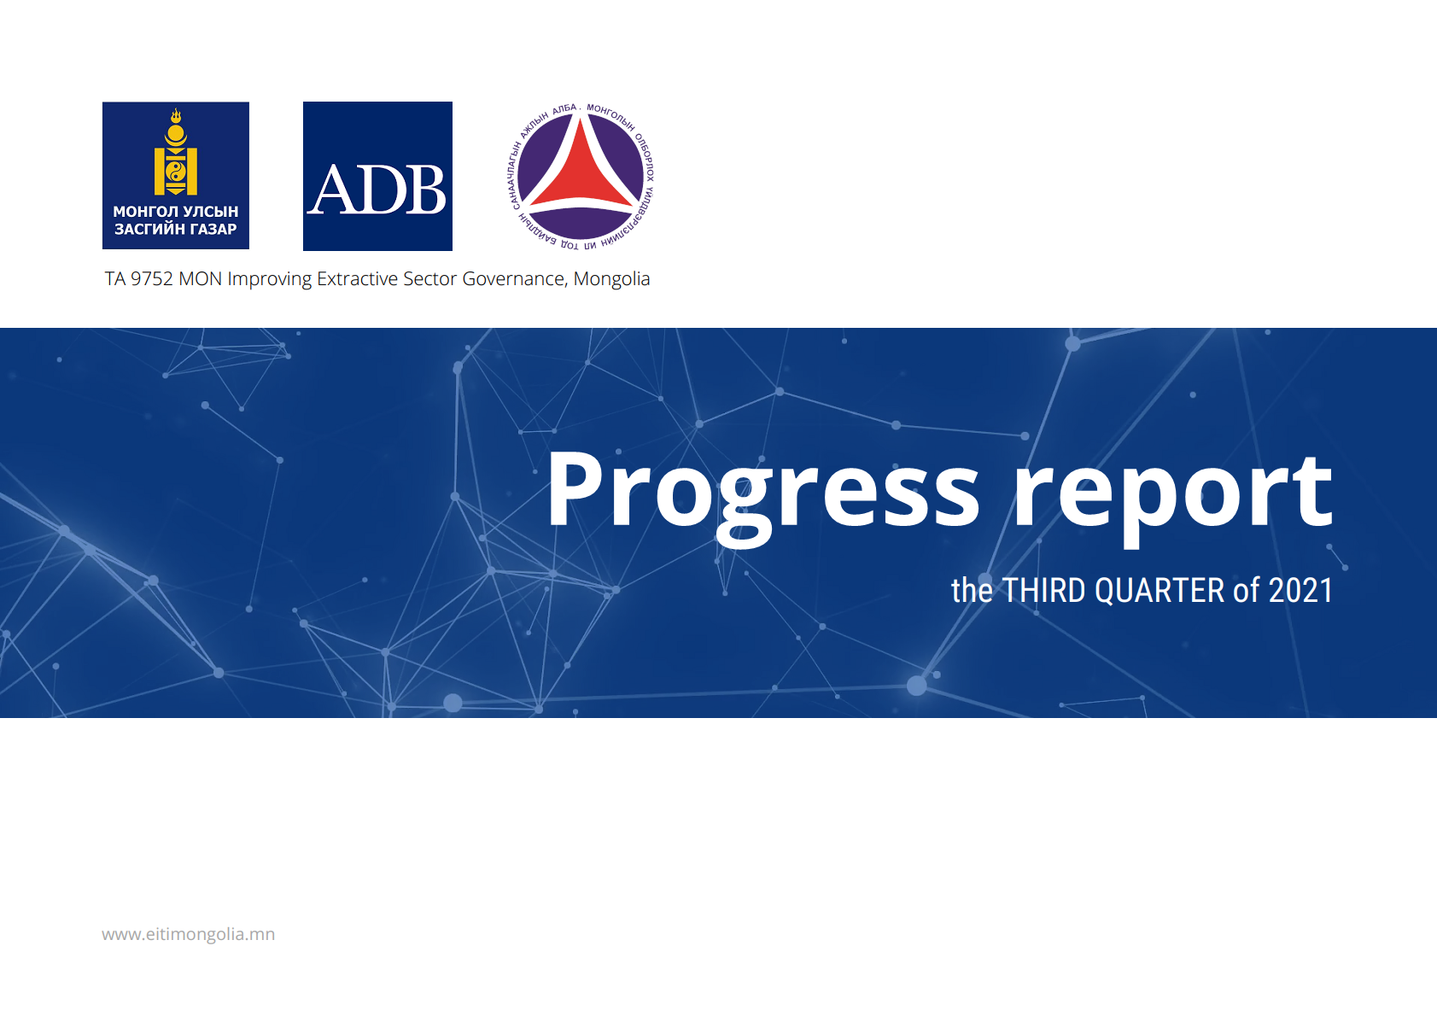
Event name | Brief description of the event | Date | Location | Organiser | Number and type of attendees | Links to further information
[Add rows as necessary]

15. Describe the MSG efforts in the period under review to consider access challenges and information needs of data users, including different genders and subgroups of citizens.
Mongolia EITI data is available, but it is considered no easy to use these data immediately, as it needs some additional development for each target group.
16. Describe other efforts by the MSG in the period under review to ensure that information is widely accessible and distributed.
Progress report for 3rd Quarter 2021 has data on these events.
[Document whether the MSG has
- produced summary reports, thematic reports or other analysis that is accessible, concise and easily understood by target audiences;
- summarised and compared the share of each revenue stream to the total amount of revenue that accrues to each respective level of government.
- undertake capacity-building efforts, especially with civil society and through civil society organisations, to improve understanding of the information and data from the reports and online disclosures and encourage use of the information by citizens, the media and others.
Provide links to supporting evidence.]

17. How could the MSG improve the accessibility and distribution of information, considering the needs of different subgroups of citizens?
Mongolia EITI Secretariat will update EITI E-reporting portal in 2022, which will be integrated into E-Government system, and develop to have a social networl friendly dashboard, which will summarize relevant data, and update existing module and API (application programming interface).

Part III: Sustainability and effectiveness
18. The MSG is requested to present any additional information and evidence related to the indicators for assessing the sustainability and effectiveness of EITI implementation.
Each indicator will be assigned 0, 0.5 or 1 points by the EITI Board. The points will be added to the overall score of the country. The assessment of performance on the indicators will draw on information provided by the MSG, publicly available sources, stakeholder consultations and disclosures by the implementing country and companies. Please see the EITI Validation Guide for further information about how performance on these indicators will be assessed.
- EITI implementation addresses nationally relevant extractive sector governance challenges. This indicator also recognises efforts beyond the EITI Standard.

MMHI and National Statistical Committee have enacted amendment to EITI Reporting templates in 2020, and amendments cover more than what is required by EITI Standard to such as procurement, use of chemicals, water, waste disposal, impact zone and etc., which are reported online, visibility of such reported data is under construction.
MMHI has enacted a procedure how to operate Open Contract portal www.iltodgeree.mn in 2021, and Secretariat had trained Aimag Authorities and introduced the procedure .
MMHI has amended annual Cooperation agreement with Aimag Governors with obligation on EITI at local area.
Mongolia Parliament has just passed the bill on disclsoure of Public information, and that will be effective from 1st of May, 2022 and under this law 67 type of informations shall be disclosed and means of disclosure shall be website, or billboard and other means. The below some information, which will be disclosed and related to extractive sector:
    - License, granting, extending, suspending and cancelling rationales, procedure, information, name of holder, address, branch office, representative, date of grant, expiry date;
8.6.3 Name, address, charter, activities direction,injected assets, profit, gain and loss report, paid tax and dividend of legal entities of state, local property;
8.6.4 Board of directors, controlling council, structure, name of members, sum of salaries and incentives for members, criteria to select, information on selection;
8.6.13 information on beneficial owners of legal entity; [Add MSG response and additional information/evidence.]

- Extractive sector data is disclosed systematically through routine government and corporate reporting.

The systematic reporting should be partly available and should be improved with developmeny E-Mongolia system. [Add MSG response and additional information/evidence]

- There is an enabling environment for citizen participation in extractive sector governance, including participation by affected communities.
The basic right of citizens to know or for information shall be guaranteed not only as legal background, but also shall open possibility of practical applications, as in economic sense, there will be saving of plenty of time and resources of ordinary citizens, researchers and stakeholders, and there will be less and less bureaucracy, and promotion to good governance in the extractive sector.
[Add MSG response and additional information/evidence.]

- Extractive sector data is accessible and used for analysis, research and advocacy.
Yes., it is often used, there are several websites.
http://www.opendatalab.mn/mininglicense, https://mmhi.gov.mn/,
https://cmcs.mrpam.gov.mn/cmcs, www.eitimongolia.mn, and http://e-reporting.eitimongolia.mn/-
[Add MSG response and additional information/evidence]

- EITI has informed changes in extractive sector policies or practices. s

EITI may be one of reasons, why Government has pushed and quickly enacted the bill of disclosure of public information. Whenever, there is consultation on disclosure of Beneficial owners, representatives of Ministry of Justice and Internal affairs were mentioning this law, stating it would be one of easest ways to push Beneficial owners data disclosure. During the round- table on BO, which was organized in May 2018 in the Government Palace, this idea was said by representative from MJIA, and the round-table was attended by Mr.E.Rich, former deputy head of EITI International Secretariat, and Ms.Valigura, regional director EITI International Secretariat,
[Add MSG response and additional information/evidence]

Part IV: Stakeholder feedback and MSG approval
19. Describe opportunities provided to stakeholders beyond MSG members to give feedback on the EITI process, including the EITI work plan.
Stakeholders beyond MSG participate often in outreach activities such as conference, webinars.
During the round- table on BO, which was organized in May 2018 in the Government Palace, idea to disclose waste disposal was said by representative from of National Committee to combat waste, which is not MSG member and the round-table was attended by Mr.E.Rich, former deputy head of EITI International Secretariat, and Ms.Valigura, regional director EITI International Secretariat,

20. Describe how any feedback from stakeholders beyond MSG members have been considered in the review of the outcomes and impact of EITI implementation.
There are some feedback, for example, waste disposal issue was included into EITI reporting template by representative from CSO in December 2019 but it was initially based on initiative of National Committee to combat waste, which is not MSG member.
21. Date of MSG approval of this submission and information on how the public can access it, e.g. link to national EITI website.
December 22nd, 2021. Link at www.eitimongolia.mn

